**Data Science   
Assignment 2 Guideline**

In this assignment, I used Windows 11 with Python to create and run the code.

To run dt.py code, you have use the command line format:

python [python script] [training file] [test file] [output file]

For example:

* **python dt.py dt_train.txt dt_test.txt dt_result.txt**

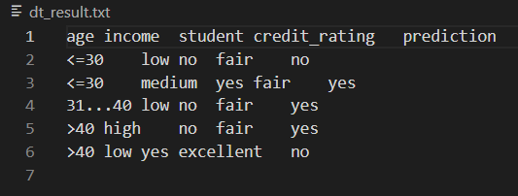



* **python dt.py dt_train1.txt dt_test1.txt dt_result1.txt**

